TRIBHUVAN UNIVERSITY

INSTITUTE OF SCIENCE AND TECHNOLOGY


Final Year Internship Report

On

“Frontend Web Development with Next.js”

At
Quantum Compilers Technology PVT.LTD

[CSC- 462]

A final year Intern Report submitted in partial fulfillment of the requirement for the
Bachelor’s Degree in Computer Science and Information Technology (BSc. CSIT) awarded by Tribhuvan University.

Submitted to:

Lumbini ICT Campus
Department of Computer Science and Information Technology
Gaindakot, Nawalpur

Submitted By:

Bipin Bhandari (24964/076)

June, 2024

MENTOR’S RECOMMENDATION FROM COMPANY

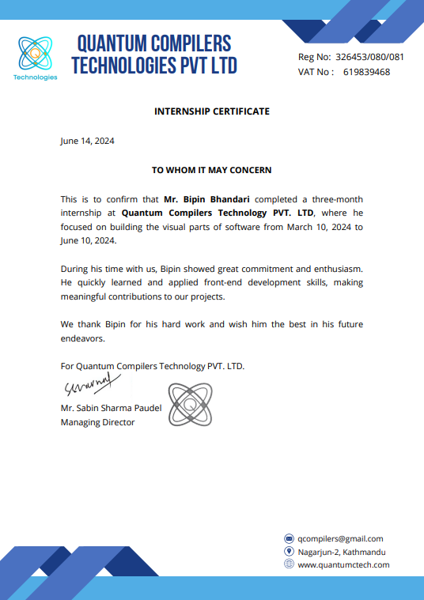

SUPERVISOR’S RECOMMENDATION
I hereby recommend that this internship report prepared by Bipin Bhandari (24964/076) on “Frontend Web Development with Next.JS” under my supervision in partial fulfillment of the requirement for the Degree of BSc. in Computer Science and Information Technology, be processed for evaluation. In my best knowledge, this is an original work in Computer Science.

……………………..
Mr. Sudhan Kandel
(Internship Supervisor)
Lumbini ICT Campus

CERTIFICATION OF APPROVAL

ACKNOWEDGEMENT
First and foremost, my sincere gratitude goes to Quantum Compilers Technology for providing the essential support and infrastructure needed to complete my internship. I would like to express my heartfelt thanks to Mr. Bipin Budhathoki, who guided me throughout the internship period, offering invaluable time and expertise to help me complete my program successfully.
I am grateful to my supervisor Mr. Sudhan Kandel, for his consistent support and guidance. His insightful ideas and knowledge were crucial to the development of this report, and his encouragement played a significant role in my learning experience during the internship
I would also like to acknowledge the contributions of my colleagues and seniors. Their indispensable support in various ways made this journey a pleasant and enriching experience. Lastly, my sincere thanks extend to all the staff at Quantum Compilers Technology, who provided unwavering assistance and administrative, technical, and statistical aspects related to this study.
Bipin Bhandari
(24964/076)

ABSTRACT
The internship program proved to be an invaluable opportunity for learning and gaining practical experience. During my internship at Quantum Compilers Technology, I was assigned various tasks by my mentors, starting with simple ones and gradually progressing to more complex challenges. I worked under the mentorship of Mr. Bipin Budhathoki, a senior full stack web/mobile developer at the company, who provided guidance throughout my journey.
My role focused on frontend web development using Next.js, where I contributed to frontend part of the project. This report highlights the essential lessons learned and the practical expertise gained during the internship. The experience not only enhanced my technical skills but also promoted effective teamwork and collaboration, leading to an enriching overall learning experience.

Keywords: Next.js, Internship, Quantum Compilers Technology, Frontend Web Development

TABLE OF CONTENT
ACKNOWEDGEMENT iii
ABSTRACT iv
LIST OF TABLES vi
LIST OF FIGURES vii
LIST OF ABBREVATIONS viii
CHAPTER 1: INTRODUCTION 1
  - Introduction 1
  - Problem Statement 2
  - Objectives 3
  - Scope and Limitations 3
1.4.1 Scope 3
1.4.2 Limitations 4
  - Report Organization 4
CHAPTER 2: ORGANIZATIONAL DETAILS AND LITERATURE REVIEW 5
  - Introduction to Organization 5
  - Organization Hierarchy 6
  - Working Domains of Organization 7
  - Description of Intern Department 8
  - Literature Review 9
CHAPTER 3: INTERNSHIP ACTIVITIES 10
  - Roles and Responsibilities 10
  - Weekly Logs 11
  - Description of the Project Involved During Internship 13
  - Tasks/Activities Performed 14
CHAPTER 4: CONCLUSION AND LEARNING OUTCOMES 15
  - Conclusion 15
  - Learning Outcome 16
REFERENCES 17
APPENDIX 18

LIST OF TABLES
Table 1: Contact Details of Company 6
Table 2: Internship Details 8
Table 3: Weekly Logs 11

LIST OF FIGURES
Figure 1: Quantum Compilers Technology Logo 5
Figure 2: Organization Hierarchy of the Company 6
Figure 3: Workflow Diagram of Tasks Performed 14
Figure 4: Booking Website Home Page 18
Figure 5: Login Page 18
Figure 6: Register Page 19
Figure 7: Admin Dashboard Page 19
Figure 8: Instructors Listing Page 20
Figure 9: Instructors Booking Page 20

LIST OF ABBREVIATIONS
API – Application Programming Interface
CEO – Chief Executive Officer
SSR – Server-Side Rendering
SSG – Static Site Generation
ISR – Incremental Static Regeneration
CSS – Cascading Style Sheets
HTML – Hypertext Markup Language
CSIT – Computer Science and Information Technology
HR – Human Resource
URL – Uniform Resource Locator
UX – User Experience
VS Code – Visual Studio Code

CHAPTER 1: INTRODUCTION

Introduction
An internship is a professional learning experience that provides meaningful, practical work related to a student's field of study or career interest. It offers students the opportunity for career exploration, skill development, and hands-on learning. As a part of the course requirement of the 8th semester of the Bachelor of Science Computer Science and Information technology (BSc CSIT) degree of Tribhuvan University, all students must complete a six credit (minimum 10 weeks/180 hours long) internship.
During my internship focused on Next.js, I had the opportunity to work alongside a team on real-world web development projects. This internship provided me with hands-on experience working with Next.js core components such routing, optimizations, middleware, styling, SSR, SSG and ISR concepts, API routes etc. Additionally, I had the chance to explore technologies such state management libraries like zustand and redux, API fetching and caching library like react-query, form handling using react-hook-form and learned more about basis of frontend development like html, css, javascript and styling using tailwindcss.
The internship offered hands-on involvement in the development of the Driving instructors booking website using the power and versatility of Next.js Framework. Throughout the project, valuable insights were gained into Next.js functionality and overall project architecture, contributing to building efficient and intuitive user interfaces. This experience enhanced my understandings of data fetching and caching using React Query, form handling with React Hook Form, styling with Tailwind CSS and many more Next.js fundamental and core concepts solidifying my skills in frontend web development.

1.2 Problem Statement
In today’s rapidly evolving technological landscape, transitioning from conventional paper-based systems to computer-based information systems has become essential for organizations. Securing a coveted graduate job offer now requires more than just academic credentials, relevant work experience plays a pivot role in career advancement. Internships have thus become indispensable for individuals seeking to distinguish themselves in the competitive job market and securing a job.
The objective of this internship project was to develop two functional web applications using modern web development technologies. The project involved creating a booking platform for driving instructors, this allowed users to select instructors, schedule bookings using an intuitive calendar interface and seamlessly purchasing packages through payment systems. Additionally, the platform provided personalized dashboards for users and instructors to manage bookings and profiles efficiently.
Historically, web development relied on antiquated technologies, leading to inefficiencies and limitations in scalability. However, by leveraging Next.js, a modern and efficient framework, the internship projects aimed to overcome these challenges. Next.js, with its robust architecture and intuitive development workflow, empowered me to create highly responsive and scalable web applications, meeting the demands of today’s dynamic digital landscape.

Objectives

1.3.1. Objectives of internship
The main objectives of this internship are:
- To gain a comprehensive understanding of the Next.js fundamental and core concepts and the ecosystem around it.
- To work on real-world projects or contribute to an ongoing Next.js project, applying theoretical knowledge to practical scenario.

1.3.2. Objectives of Project
The main objective of this internship project is to develop the frontend part of the fully functional driving instructors booking website using Next.js framework, along with the fundamental knowledge of HTML/CSS, JavaScript, TypeScript and TailwindCSS. The booking site should allow users to view and select different instructors based on location, schedule the bookings using calendar, purchase the package using payment system, a dashboard for users/instructors managing profile and bookings and admin dashboard for administrators to manage users/instructors, create new packages and view analytics of the site.

Scope and Limitations

Scope
An internship is like a hands-on learning experience where you get to learn and practice skills in a specific area or job field. It’s a chance to try out different roles and see which one you might want to do in the future. Internships also make your resume look better, give you a glimpse into what it’s like to work in a real job, and let you meet people who could help you in your career later on.
As for my internship, I was involved in developing a driving instructor booking website.
The scope of the Driving Instructor Booking Website created using Next.js are:
- To allow users to register/login, purchase packages, search instructors and schedule a booking.
- To create a dashboard for users/instructors like dashboard for viewing bookings details and managing profiles.
- To create an administrative dashboard for viewing users and instructor’s details and bookings, managing orders/payments and viewing analytics of the site.

Limitations
The limitations faced during the internship period are as follows:
- Working remotely meant missing out on the physical office environment.
- Keeping up with new technologies and updates posed a constant challenge.

Report Organization
Chapter1: Introduction of the Project, Problem Statement, Objectives, Scope and limitation
Chapter2: Introduction to organizations, Organizational hierarchy, working domain of the Organizations, Description of the intern Department, Literature review
Chapter3: Roles and Responsibilities, Weekly log, Description of the Project Involved during Internship, Tasks/Activities such as Requirement, system design, implementation of the project that indicates how the system is implemented what tools, platforms have been used. Testing clarifies the system workflow.
Chapter4: Conclusion marks an end to the document by summing up the entire project and also opening the door further for research in improving the developed system. The lesson learnt is also included in this chapter.

CHAPTER 2: ORGANIZATIONAL DETAILS AND LITERATURE REVIEW

Introduction to Organization
Quantum Compilers Technology is a forward-thinking software development company known for its expertise in crafting cutting-edge digital solutions. Specializing in customized web and mobile app development. It aims in creating interactive user interfaces and robust backend frameworks to address to address real world challenges. Company prioritize understanding the client’s needs and translating them into user-friendly solutions, aligning with the mission to ‘Customize Values’.

Quantum Compilers has a skilled team, including the CEO, lead engineers, instructors, and intern guides. The company focuses on providing valuable software solutions that help clients achieve their business goals. They offer innovative software, technical support, and expertise. Quantum Compilers has been helping professionals and students advance their tech careers for years, offering high-quality training programs tailored to meet student’s needs.

Figure 1: Quantum Compilers Technologies Logo

Table 1: Contact Details of Company

Company Name: | Quantum Compilers Technologies PVT.LTD
Address: | Nagarjun-2, Kathmandu, Nepal
Contact: | +977 9860100435
Mail: | qcompilers@gmail.com
Website: | https://quantumctech.com
Opening Hours: | 9am – 5pm

2.2 Organization Hierarchy
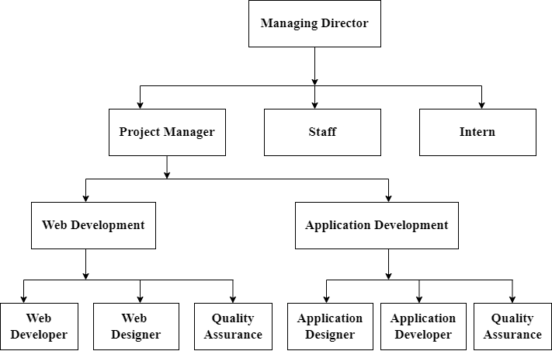
The organization ranks employees at various levels, each level is one above the other. Dreamwork comprises an administrative team along with interns, junior and senior programmers and web designers.

Figure 2: Organization Hierarchy of the Company

CEO: The CEO is responsible for carrying out existing plans and policies, improving the company's finances, supporting digital business changes, and planning future strategies.
HR: HR handles the employee life cycle, including recruiting, hiring, onboarding, training, and firing employees, as well as managing employee benefits.
Project Manager: The project manager oversees the daily management of the project, handling the scope, schedule, budget, risks, quality, and resources.
Project Leader: A project leader guides the team and ensures the project is completed successfully.
Team Leader: A team leader provides direction and instructions to the group working on a project or several projects.
Developer: Developer designs and builds the application.
Interns: Interns focus on learning, fixing small bugs, and performing tasks like testing, adding new features/functionalities and fixing design issues. They are involved in almost all areas of the project.

Working Domains of Organization
Quantum Compilers Technologies provides multiple services in website and application design and development as well as WordPress development and machine/deep learning. Quantum Compilers Technologies has highly-skilled, experienced and knowledgeable team. The areas of expertise of the organization are:
    - Website Development: Quantum Compilers mainly deals with the aspect of building, designing websites, which includes coding and writing markup ranges as creating plain text pages to complex web-based applications, social network applications and electronics business applications.
    - Application Development: Quantum Compilers deals with creating a mobile application or a set of programs to perform the different tasks that a business requires. From calculating monthly expenses to scheduling sales reports, applications help businesses automate processes and increase efficiency.

    - Machine/Deep Learning: Quantum Compilers deal with an application of AI that includes algorithms that parse data, learn from that data, and then apply what they’ve learned to make informed decisions as well as to manage data and information.
    - WordPress Development: Quantum Compilers deal with developing and publishing software that can be installed locally on a web server and viewed on a proprietary web site or hosted in the cloud and viewed on the WordPress web site.

Description of Intern Department
I worked for a total of eight weeks as an intern at Quantum Compilers Technologies. The details of my internship period in the organization are summarized in the following table:
Table 2: Internship Details

Start Date: | 1st April, 2024
End Date: | 1st June, 2024
Total Duration: | 2 months
Position: | Intern as a Frontend Web Developer
Mentor: | Mr. Bipin Budhathoki
Office Hour: | 9am – 5pm

2.3 Literature Review
Web development is the process of creating websites and web application. For this internship project, understanding web development principles and using appropriate frameworks is crucial. A critical aspect of any website is providing a positive user experience. UX design involves optimizing site navigation, ensuring mobile responsiveness, and making content easily accessible to users. Following UX design principles enhances user engagement and encourages return visits. With more users accessing websites on various devices, implementing responsive web design is essential. This technique ensures that the website adapts and looks appealing across different screen sizes, including smartphones, tablets, and desktops. Additionally, incorporating social media sharing buttons and widgets facilitates easy content sharing, increasing the site’s visibility and audience reach. Integrating social media platforms can help foster user engagement and community building.
In conclusion, this literature review highlights essential components for building a successful driving instructor booking website during the internship. By focusing on web development frameworks, prioritizing user experience, implementing responsive design, and integrating social media, the intern can create a professional and engaging platform. Employing these best practices will enhance the site’s functionality, visibility and overall success.

CHAPTER 3: INTERNSHIP ACTIVITIES

Roles and Responsibilities
As an intern at Quantum Compilers, I had several responsibilities assigned by my mentor, MR. Bipin Budhathoki. These tasks were crucial to my learning and growth during the internship. The main responsibilities I carried out as a Next.js intern included:
    - Assisting in Next.js Development: Working closely with senior developers to build and maintain websites using Next.js framework. This involved writing clean and efficient Typescript code, implementing features, and ensuring the site's functionality.
    - Data Fetching/Caching/Invalidating: Utilizing popular library (Tanstack React Query) for data fetching, caching and invalidating as per need to improve the performance and user experience of web applications.
    - Form Handling: Using popular library (React-Hook-Form) to handle form validation and submission, ensuring a smooth, secure and efficient user experience.
    - Styling with TailwindCSS: Applying TailwindCSS to style components and create a modern, responsive design for web applications.
    - Bug Fixing and Troubleshooting: Identifying and resolving bugs or issues within the existing applications. Debugging and testing code to ensure proper functionality and user experience.
    - Version Control and Collaboration: Using version control systems like Git to manage codebase changes and collaborate effectively with other team members.
    - Code Review: Participating in cod reviews providing feedback, and learning from feedback given by senior developers.
    - Testing and Quality Assurance: Writing unit tests and performing quality assurance to ensure the application meets the given requirements and standards and functions correctly.

Weekly Logs

Table 3: Weekly Logs

Week | Start Date | End Date | Activities
Week-1 | 1st April | 5th April | Attended orientation learned about company’s culture and introduction to the team members, project setup in VS Code, git setup and necessary tools installed.  .
Week-2 | 7th April | 12th April | Studied how the instructors booking websites are made the responsive landing page, dashboard layout and tested the calendar in react.
Week-3 | 14th April | 17th April | Made instructors table did CRUD operations in dashboard, made the flow for booking (view calendar, select package, fill form, payment).
Week-4 | 19nd April | 26th April | Connected the booking flow to the backend api, used next-auth library for authentication, dynamic dashboard according to user roles.
Week-5 | 28th April | 3rd May | Bug fixes in the booking flow of the instructor, made different flow for logged/not-logged in users, made the booking flow page responsive.
Week-6 | 5th May | 10th May | Made booking details table in dashboard, learned about CommBank for payment integration and added calendar in instructor dashboard to view their respective bookings.
Week-7 | 12th May | 17th May | Added locations table in dashboard for doing CRUD operation, added pagination in all tables, integrated payment form with backend.
Week-8 | 19th May | 24th May | Added searching instructors based on the location feature in the site, modified the booking flow added location selection in first while booking the instructor, added booking details page in dashboard.
Week-9 | 26th May | 31st May | Added packages table in admin dashboard for doing CRUD operation, fixed all the build errors/bugs and made code ready for deployment.
Week-10 | 26th May | 31st May | Added packages table in admin dashboard for doing CRUD operation, fixed all the build errors/bugs and made code ready for deployment.
Week-11 | 26th May | 31st May | Added packages table in admin dashboard for doing CRUD operation, fixed all the build errors/bugs and made code ready for deployment.
Week-12 | 26th May | 31st May | Added packages table in admin dashboard for doing CRUD operation, fixed all the build errors/bugs and made code ready for deployment.

Description of the Project Involved During Internship
During my internship, I had the opportunity to work on a Driving Instructor Booking Website. This platform was designed to be user-friendly and cater to both driving students and instructors. My primary responsibility was to implement the front-end of the site, handling date fetching, form/calendar handling and ensuring a seamless user experience.
The Driving Instructor Booking Website features an intuitive layout and user interface, allowing users to easily navigate through various sections of the site. Users can register or log in, search for driving instructors, filter them based on location, purchase lesion packages, and schedule bookings. The website’s design ensures that users can quickly find and book their preferred driving instructors.
Key features of the project include:
    - User Registration and Login: Users can create accounts and log in using email/password or social login to manage their bookings and profile.
    - Search Feature: Uses can search for particular instructors based on the location.
    - Package Purchase and Booking: Users can view available lesson packages, make purchases, and schedule bookings with driving instructors.
    - User and Instructor Dashboards: Dedicated dashboards for users and instructors to view booking details, manage profiles, and tack lesson schedules.
    - Administrative Dashboard: An Admin panel for managing user and instructor details, overseeing bookings, handling payments, and viewing site analytics.
    - Responsive Design: Ensuring the website is mobile-friendly and adapts to various screen sizes, providing a smooth experience on smartphones, tablets, and desktops.
    - Multimedia Integration: Incorporating images and other multimedia elements to enhance the visual appeal and provide a richer user experience.

.

Tasks/Activities Performed
During the Internship period, I undertook various tasks that included understanding the work culture and system requirements through weekly team meetings, designing the Instructors Booking Site based on the provided requirements, and implementing the necessary functionality. Additionally, fixing bugs and errors was a significant part of my responsibilities.

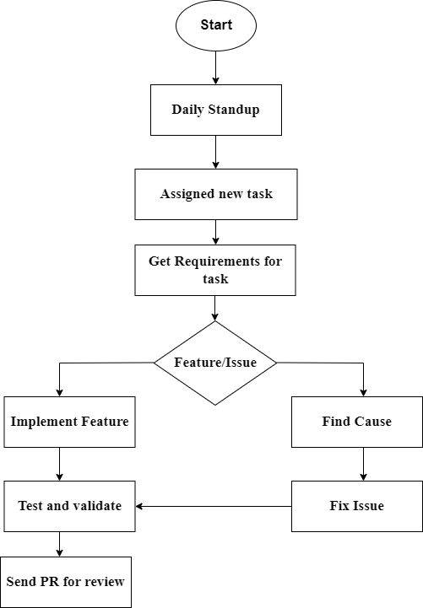

Figure 3: Workflow Diagram of Tasks Performed

CHAPTER 4: CONCLUSION AND LEARNING OUTCOMES

Conclusion
The internship at Quantum Compilers provided a great platform for enhancing my knowledge and skills and web development, specifically using Next.js. It gave me practical experience and a good understanding of working in a professional team environment. Working on projects related to my interests allowed me to dive deeper into the core details of Next.js and front-end web development. The main goal of the internship was to bridge the gap between academic learning and real-world application, and it successfully achieved that.
During the internship, I learned the importance of effective communication for coordinating tasks within the team and the collaborative spirit needed to achieve project goals. Bringing ideas to life through practical implementation highlighted the importance of creativity and innovation in software development. Working within time constraints emphasized the value of time management and prioritization to deliver quality results. Gathering and analyzing relevant information for software development broadened my understanding of the industry’s requirements and the key aspects of the development process.
Overall, the internship program was immensely beneficial for my career development. The hands-on experience in handling real-world problems and following organizational rules and regulations enhanced my professionalism. It also boosted my technical knowledge and provided valuable professional expertise, which will serve as a strong foundation for my future career. The valuable lessons learned during this internship will undoubtedly play a crucial role in my journey as a skilled a competent Next.js developer.

Outcome
The internship journey at Quantum Compilers has been a transformative experience, providing invaluable learning outcomes that go beyond technical skills. Throughout the internship, I gained a deeper understanding of front-end development with Next.js, alongside acquiring essential life skills and professional insights that will positively impact my future career endeavors. Here are some of the key outcomes:
    - Technical Expertise and Skill Development: One of the main outcomes was enhancing my technical expertise and skills. Working on real-world projects and collaborating with experienced developers exposed me to a wide range of technologies. I gained proficiency in Next.js, React, Tailwind CSS and other related tools/libraries of the frontend web ecosystem.
    - Project Contributions and Impact: As a Next.js developer at Quantum Compilers, I had the chance to actively contribute to various projects, including a driving instructor booking website. Seeing my contributions come to life and being used by real users was a rewarding experience.
    - Team Collaboration and Communication: Working at Quantum Compilers fostered my abilities in team collaboration and communication. Interacting with other developers, designers, project managers, and stakeholders enhanced my ability to work in a team and communicate technical concepts effectively.
    - Problem-Solving: While working on various projects, I encountered different problems and bugs. Debugging issues, optimizing code, and finding solutions to complex problems were all part of my role as a Next.js Developer.
    - Continuous Learning and Growth: The tech industry is constantly evolving, and Quantum Compilers encouraged and supported continuous learning and growth. The internship journey continues beyond the internship.

REFERENCES
Use the APA referencing standard

APPENDIX


Figure 4: Booking Website Home Page
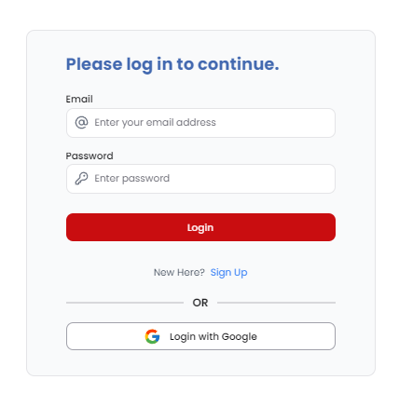

Figure 5: Login Page

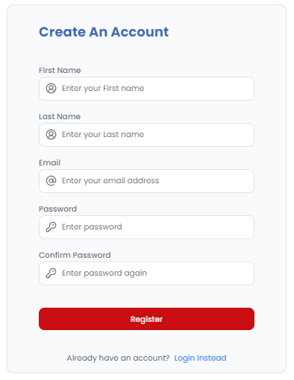

Figure 6: Register Page

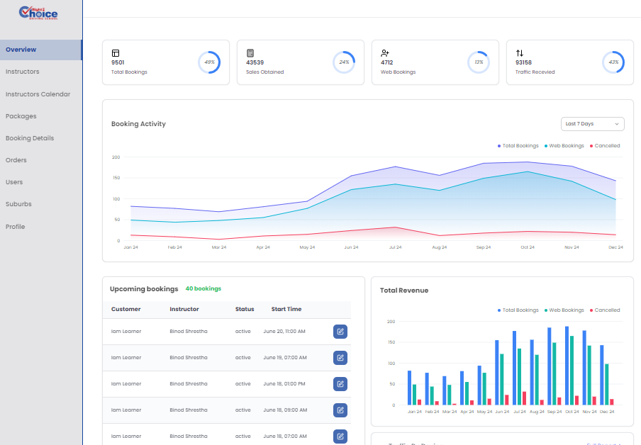

Figure 7: Admin Dashboard Page

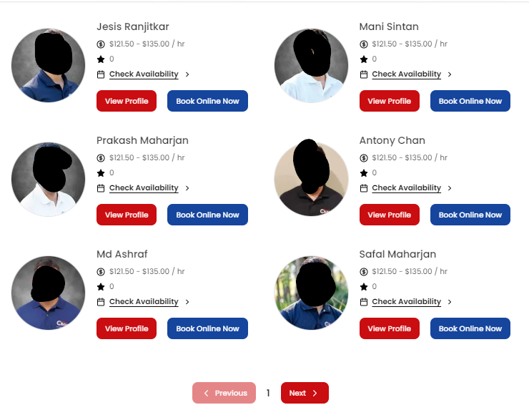

Figure 8: Instructors Listing Page

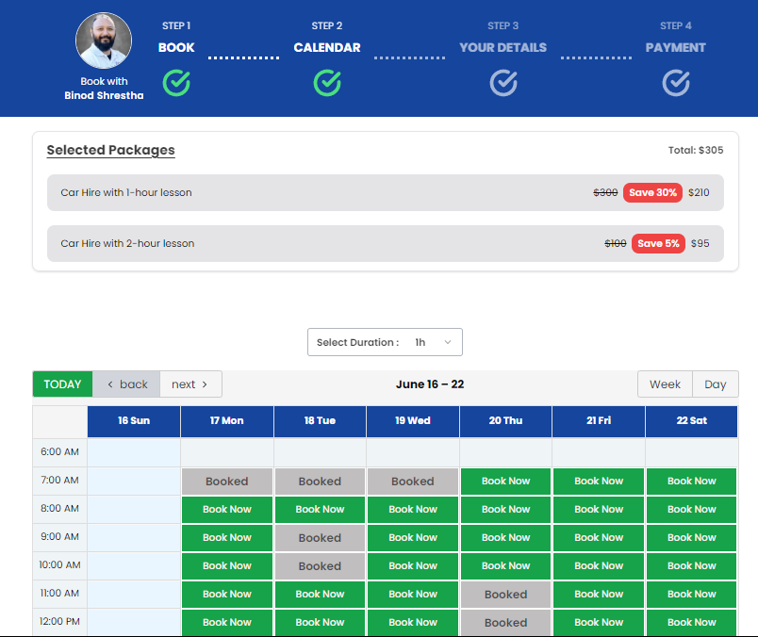

Figure 9: Instructors Booking Page

